How to extract DNA from a kiwi fruit | Sat, 1st Jul 2006
Part of the show Sex Chromosomes, Genetics and Food Webs

What you need

A kiwi fruit (an onion will do if you don't have a kiwi)
5g washing up liquid or hand soap
2g salt
100ml tap water
100ml of ice cold alcohol (white rum or methylated spirits are best). Put in freezer for at least 30 mins. kettle
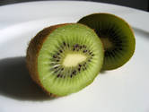
3 jars
large basin
something to mash the kiwi with
sieve or coffee filter paper
knife (be careful!)

What to do
1 - Peel the kiwi fruit and chop it into small chunks. You don't want the skin because it's mostly dead and doesn't have much DNA in it.
2 - Put the chunks in a jar and mash the kiwi as much as you can. This is to break up some of the cells and provide a large surface area over which to extract the DNA.
3 - Mix together the washing up liquid, the salt and the tap water and stir slowly until the salt has dissolved. Don't stir too fast or else you'll get lots of bubbles! This mixture is also known as an extraction buffer.
4 - Add the extraction buffer to the mashed up kiwi and MASH! The more you mash, the more DNA you will get out at the end.
5 - Incubate the kiwi and buffer mixture at 60 degrees Centigrade for 15 minutes. To make your own incubator, take a large basin and half fill it with boiling water from a kettle. To reduce the temperature, add about the same amount again of normal tap water. Using a thermometer will help you reach a more precise temperature. Carefully put the jar with the kiwi into the incubator and leave to stand for 15 minutes. Incubation helps to break up the cells further and starts to degrade some of the cell's proteins.
6 - Remove the jar from the incubator and filter the kiwi mixture through a fine sieve or coffee filter paper into another jar. This removes all the unwanted lumps and bits of kiwi fruit. You should be left with a green liquid, and this contains the kiwi fruit DNA.
7 - Take the ice cold alcohol and pour it slowly down the side of the jar. The alcohol will form a transparent layer on top of the kiwi mixture, as the alcohol is less dense.

What may happen
Where the layer of ice cold alcohol meets the kiwi mixture underneath, you will see a white jelly-like substance forming. You can hook the DNA out with a hook made from a paperclip or something similar.

Why does it happen?
All living things are made up of cells, and each cell contains a complete copy of the organism's DNA. So you could extract DNA from any kind of living material.
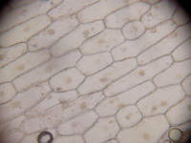 | Here are some cells from an onion (they are a lot easier to photograph than Kiwi cells)
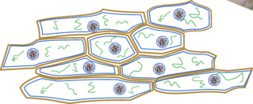 | The cells are made up of strong cell walls (yellow), fatty cell membranes (blue) and contain a nucleus with DNA inside (black) and lots of proteins (green)
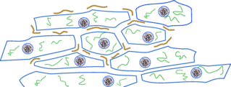 | The high temperature breaks down the cell walls exposing the cell membranes.
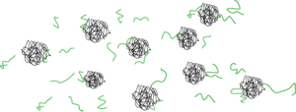 | The detergent in the washing up liquid dissolves the fatty cell membranes.
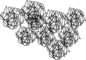 | Because Kiwi contains protease enzymes which break up proteins they get destroyed. It is also why it can hurt if you eat too many - they enzymes start to breakdown the proteins that make up your mouth.  The salt makes the DNA stick together. The DNA doesn't dissolve in alcohol so it coagulates to form a jelly like substance which you can pick up.
The DNA you have extracted has come from billions of kiwi fruit cells, which is why you can see it so easily. If you were able to unravel the DNA in just one human cell and stretch it out, it would be two metres long. However as DNA is so thin, you would not be able to see it without an incredibly powerful microscope.
To see an animated version of a DNA extraction performed with an onion, then go to the
Cambridge Hands on Science DNA extraction page.

